**Mini Project Report on**



**THRIFT STORE FOR SELLING CLOTHES WITH INTERACTIVE WEB APPLICATION**



**Submitted in partial fulfilment of the requirement for the award of the degree of**

**BACHELOR OF TECHNOLOGY**

**IN**

**COMPUTER SCIENCE & ENGINEERING**

**Submitted by:**

**Student Name : Asad Siddiqui** **University Roll No. 2021578**

***Under the Mentorship of***

**Mentor Name - Ms Ankita Nainwal**



**Department of Computer Science and Engineering**

**Graphic Era (Deemed to be University)**

**Dehradun, Uttarakhand**

**January-2025**



**CANDIDATE’S DECLARATION**

I hereby certify that the work which is being presented in the project report entitled **“Thrift Store for Selling Clothes with Interactive Web App”** in partial fulfillment of the requirements for the award of the Degree of Bachelor of Technology in Computer Science and Engineeringof the Graphic Era (Deemed to be University), Dehradun shall be carried out by the under the mentorship of **Ms Ankita Nainwal** , Department of Computer Science and Engineering, Graphic Era (Deemed to be University), Dehradun.

Name : Asad Siddiqui

University Roll no. 2021578

**Table of Contents**

|  |  |  |
| --- | --- | --- |
| **Chapter No.** | **Description** | **Page No.** |
| **Chapter 1**    **1.1** | **Introduction**  Overview of the thrift store and its concept through an interactive web application. |  |
| **Chapter 2**    **2.1** | **Literature Survey**  Review of similar online thrift store platforms and their impact on the second-hand clothing market. |  |
| **Chapter 3**  **3.1**    **3.2**  **3.3** | **Methodology**  Completed the main HTML structure, including:   * Homepage for welcoming users * Product listing page * Checkout page for purchases   Styled the site with CSS for a clean, modern look.  Adding JavaScript to enhance interactivity. |  |
| **Chapter 4**  **4.1** | **Result and Discussion**  Presentation of website functionality, including user experience and interactivity. |  |
| **Chapter 5** | **Conclusion and Future Work**  **References** |  |
| **5.1**  **5.2** | Conclusion on the successful development of the thrift store web application.  Future plans for expanding product categories, adding customer reviews, and implementing payment gateways. |  |

**Chapter 1**

**Introduction**

* 1. **Overview of the thrift store and its concept through an interactive**

**web application**

The concept of a thrift store revolves around selling second-hand or pre-owned items, particularly clothing, at affordable prices. In the context of this project, the thrift store is built as an interactive web application designed to offer a convenient, user-friendly platform for purchasing second-hand clothing online. The website's primary goal is to create an accessible, eco-friendly, and budget-friendly alternative to traditional retail shopping by offering gently used clothes to a wide range of customers.

Through the interactive web application, users can browse a variety of clothing items, from shirts and pants to jackets and accessories. The site features a clean and modern design that enhances the shopping experience by providing intuitive navigation and search functionality. Customers can view detailed product listings, check availability, and make purchases directly through the checkout page.

This web-based approach aims to reach a larger audience by providing a seamless and engaging online shopping experience. It also embraces the values of sustainability and recycling by promoting the reuse of clothing, helping reduce waste, and lowering the environmental impact of the fashion industry. By incorporating interactive elements such as product filtering, a shopping cart, and secure checkout, the thrift store enhances customer engagement and satisfaction, ensuring a positive and memorable shopping experience.

**Chapter 2**

**Literature Survey**

**2.1 Review of similar online thrift store platforms and their impact on the second-hand clothing market.**

The online second-hand clothing market has seen significant growth in recent years, driven by platforms that offer consumers a more sustainable and affordable way to shop. Several successful online thrift store platforms, such as Poshmark, Depop, and ThredUp, have paved the way for the digital resale of pre-owned fashion. These platforms have not only revolutionized the thrift shopping experience but also contributed to the broader movement toward eco-conscious consumerism.

Poshmark, for example, allows users to buy and sell gently used clothing, accessories, and shoes, while also providing a social networking aspect, which encourages community engagement and boosts sales. Depop, which focuses on a younger audience, emphasizes unique, vintage, and trendy items, creating a marketplace for fashion-forward second-hand goods. ThredUp, on the other hand, offers a more streamlined shopping experience, focusing on high-quality and well-curated items, with a focus on sustainability and environmental impact.

These platforms have reshaped the second-hand clothing market by making it more accessible, convenient, and trustworthy for consumers. They promote sustainable fashion by extending the lifecycle of clothing, reducing the demand for new production, and decreasing waste. Additionally, they have empowered individuals to monetize their unused clothing, contributing to the growth of a circular economy.

The success of these platforms highlights the potential for further expansion of online thrift stores, encouraging more consumers to embrace second-hand shopping as a viable and eco-friendly alternative to fast fashion.

**Chapter 3**

**Methodology**

**3.1 Completed the main HTML structure**

The development of the thrift store web application involved a systematic approach, focusing on creating the core structure and functionality. The main HTML structure was completed with the following components:

1. **Homepage for Welcoming Users**: The homepage serves as the first point of interaction for users. It provides an inviting and clean design that introduces the thrift store concept. It includes navigation links to the product listing page, login/registration options, and other essential sections like customer support and contact information. The homepage is designed to offer a user-friendly experience and direct users to the products they are looking for with minimal effort.
2. **Product Listing Page**: This page showcases the available products, allowing users to browse through various categories of clothing, such as shirts, pants, jackets, and accessories. Each product is displayed with relevant details, including images, descriptions, and prices. The layout is designed to be easily navigable, with sorting and filtering options that enable users to find products based on their preferences. The product listing page serves as the primary interface for shopping, offering an interactive experience for customers.
3. **Checkout Page for Purchases**: The checkout page is where users finalize their purchases. It collects necessary details such as total amount information and voucher offer. A simple form design, clear call-to-action buttons, and validation measures are implemented to minimize user errors and enhance the user experience during the checkout process.

**3.2 Styled the site with CSS for a clean, modern look.**

To enhance the overall user experience and ensure a visually appealing interface, the website was styled using CSS, focusing on creating a clean and modern aesthetic. The key design elements include:

1. **Color Scheme**: A minimalist color palette was chosen to create a visually soothing experience while ensuring that product images and key content stand out. Neutral tones, such as whites and grays, were paired with accent colors to highlight buttons, product details, and links, making navigation intuitive and engaging.
2. **Typography:** Modern and legible fonts were selected to ensure readability across all devices. Headings and body text were styled with appropriate font sizes and weights to create a clear visual hierarchy, making it easy for users to scan and read product descriptions, titles, and other content.
3. **Responsive Layout**: The website was designed with a mobile-first approach, ensuring that it adapts smoothly to different screen sizes, from desktops to smartphones. Flexbox and CSS Grid were used to structure the content in a way that adjusts based on the user’s device, making the site accessible and user-friendly across all platforms.
4. **Whitespace and Spacing:** Ample whitespace was incorporated around elements such as buttons, images, and text to create a clean layout and avoid a cluttered look. Proper padding and margins were used to ensure content is well-organized, improving the user’s ability to focus on the product without distractions.
5. **Interactive Elements:** Hover effects and transitions were added to buttons and links, providing users with visual feedback on their interactions. This makes the site more dynamic and engaging, encouraging users to explore and take action, such as adding items to the cart or completing a purchase.

**3.3 Adding JavaScript to enhance interactivity.**

JavaScript was integrated into the thrift store web application to improve user interactivity and make the site more dynamic. The addition of JavaScript brings the following interactive features:

1. **Product Filtering and Sorting:** JavaScript enables users to filter products based on categories such as type, size, color, or price range. It allows for real-time updates to the product listing without needing to reload the page. Sorting options, such as price low to high or high to low, are also implemented for better usability.
2. **Interactive Shopping Cart**: JavaScript enhances the shopping cart functionality by allowing users to add, remove, and update quantities of products dynamically. The cart updates automatically, providing immediate feedback to users about their total cost and the number of items in their cart without requiring a page reload. This makes the shopping experience faster and more fluid.
3. Form Validation: To ensure users submit accurate information, JavaScript is used for validating forms on the checkout page. It checks for empty fields, invalid voucher formats, or incomplete size, providing real-time error messages to guide users in correcting mistakes before submission. This ensures smooth transactions and improves the overall user experience.
4. **Dynamic Price Updates:** When a user changes the quantity of items in the cart, JavaScript dynamically updates the total price, ensuring the user sees accurate pricing information in real-time.
5. **Modal Windows for User Interaction:** JavaScript is used to create modal windows for actions such as displaying product details, confirming actions like adding items to the cart, or showing success messages during checkout. These modals appear without navigating away

**Chapter 4**

**Result and Discussion**

**4.1 Presentation of classification results (accuracy)**

The website offers a seamless user experience, featuring easy navigation, dynamic product listings, and an interactive shopping cart. JavaScript enhances interactivity by enabling real-time product filtering, price updates, and form validation. These elements ensure smooth browsing, efficient purchasing, and a responsive interface, making the website both functional and engaging.

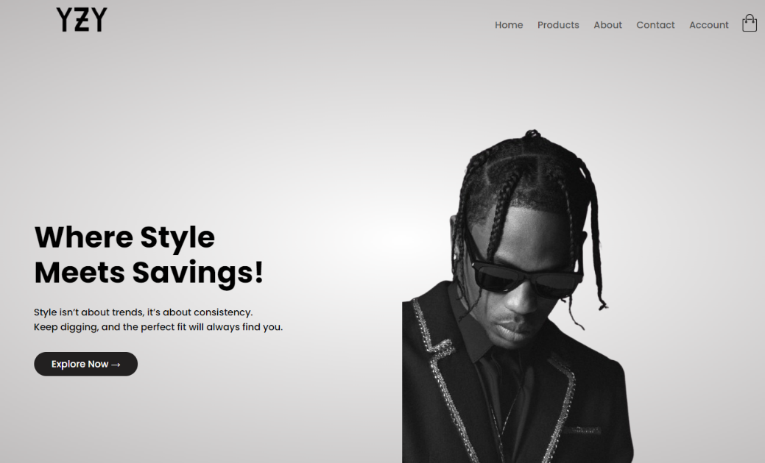

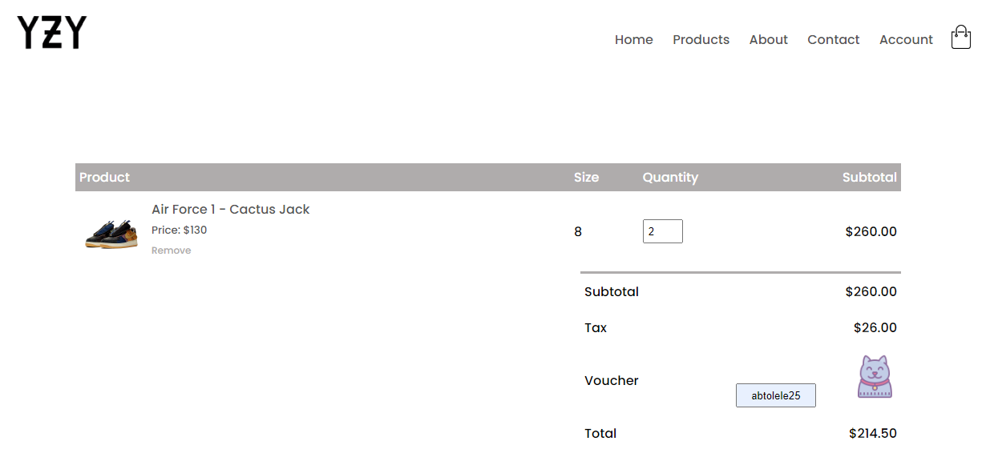

**Chapter 5**

**Conclusion and Future Work**

**5.1 Conclusion on the successful development of the thrift store web application.**

The thrift store web application has successfully been developed, providing a user-friendly platform for browsing and purchasing second-hand clothing. With a clean design, interactive features, and smooth functionality, the application meets the goals of promoting sustainability and offering affordable clothing, while ensuring an engaging and seamless shopping experience for users.

**5.2 Future plans for expanding product categories, adding customer reviews, and implementing payment gateways.**

Future plans for the thrift store web application include expanding the product categories to offer a wider range of items such as shoes, accessories, and seasonal clothing. This will attract more customers and enhance the store’s variety. Additionally, customer reviews will be integrated to build trust and provide valuable feedback for potential buyers. Reviews will allow users to share their experiences, helping others make informed decisions and increasing the credibility of the platform.

Another key development will be the implementation of secure payment gateways, such as PayPal, Stripe, or credit card payments, to provide customers with a safe and convenient way to complete their purchases. This will facilitate seamless transactions, encouraging more customers to shop online confidently.

These enhancements will further improve the user experience, increase sales, and expand the store’s reach, positioning the platform as a trusted, all-encompassing destination for affordable, sustainable fashion.